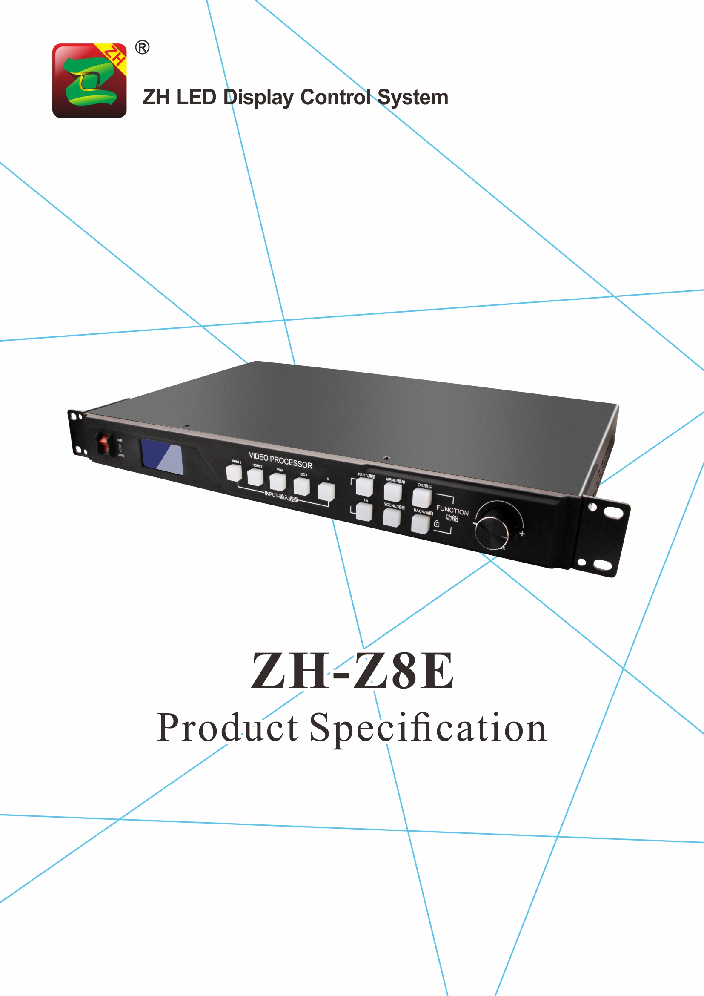

Product Specification
ZH-Z8E

I. Product Introduction:

ZH-Z8E is one three-in-one product developed for LED large-screen display systems, integrating asynchronous, high-definition video processors and sending cards. It adopts industry-leading lossless zoom technology, supports high-definition HDMI/DVI input and standard Gigabit Ethernet port output, and provides customers with a synchronous LED large-screen high-definition display solution; new asynchronous expansion card is added to meet various needs of customers in different scenarios; The integrated software simplifies the customer's operation process; the standard 1U chassis makes engineering installation more convenient and quicker, and truly achieves the purpose of multi-scenario and minimal operation. ZH-Z8E supports one-key switching between partial and full-screen modes, and one-key switching between synchronous and asynchronous modes. The screen transition is smooth and stable. ZH-Z8E supports online upgrades to ensure that customers upgrade new functions from time to time.

II. Functional Features
ZH-Z8E is a full-color series player control system, its functions are as follows:
- Use the same refresh technology as the synchronization system;
- Support cascaded receiving card, realize the support of any size screen;
- SDK development kits are provided for all series;
- Support HD video hard decoding;
- Support audio sync audio input and output, 3.5mm standard audio output interface;
- Support U disk to play videos and pictures directly;
- Support 2 HDMI inputs, 1 VGA input, 1 HDMI output;
- Support synchronous, asynchronous local and remote one-key switching;
- Support one-key switching between partial and full screens in synchronous mode;
- Support picture zoom function;
- Support manual switch, timing switch;
- Support extended sensor and other functional interfaces;
- Support U disk, network cable to enable wireless WiFi hotspot (AP mode) and access to LAN (STA mode) to achieve cluster management;
- Support UDP network communication protocol;
- Support DHCP to automatically obtain IP address;
- Support one-key whole screen test;
- Support simultaneous playback of multiple video windows;
- Support EDID setting;
- Support brightness timing adjustment;
- Support Mobile (Android + Apple) software sending;
- Support local server and remote server to publish content;
- Support program sequence, timing and other playback methods;
- Support emergency information insertion;
- Support weather forecast, web pages, streaming media, etc.;
- Support standard databases such as json and mysyq;
- Support docking of data acquisition instrument, PLC, etc.;
- Support log, screen status query;
- Supports simultaneous playback of multiple devices;
- Support cloud login dynamic verification, support grouping, classification, monitoring, audit and other authority management.

III. Function Parameters
System Parameter
CPU | Eight-core A53，1.5GHz
Control system | Android 5.1
Storage | 8G（system about 2.5G）
Loading area | 5.2 million  Max W: 8192, Max H: 2160

Communication and Interface
Support WIFI;
Support USB;
Support 100 m / 1000 m network adaptive;
Support server cluster;

Load Parameters
Support Gigabit to cascade receiving card, maximum support 5.2 million points;

IV. Hardware Introduction:

The Front Panel

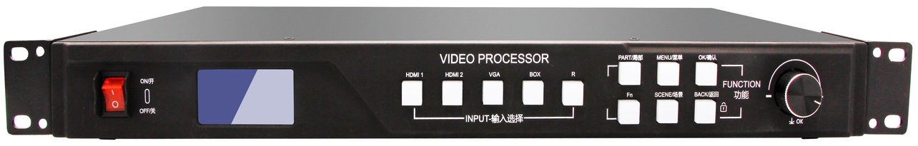
Switch
Knob
Button
LCD

Switch | The power switch
LCD | Displays detailed prompts for user
Knob | Adjust the LED screen resolution and confirm

Button Part Manual
INPUT |  | FUNCTION
HDMI 1 | HDMI 1 signal input button | PART/局部 | Partial/full screen switching
HDMI 2 | HDMI 2 signal input button | MENU/菜单 | Enter advanced settings mode
VGA | VGA signal input button | OK/确认 | Select conform button
BOX | Async play selection key | Fn | Compound key
R | Reserved button | SCENE/场景 | The call button for default scenes
 |  | BACK/back | Back to the previous menu/lock function

The Back Panel

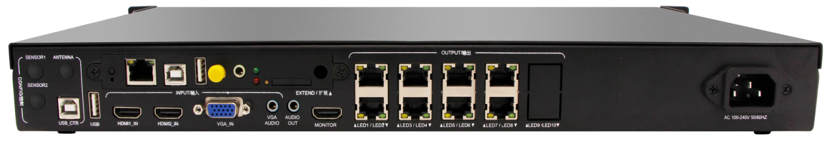

Power Port
Output Port
Control Port
Input Port

CONFIG/Control Port |  | INPUT/Signal Input Port |  | OUTPUT/Signal Output Port
SENSOR1 | Extended sensor interface 1 | USB | Update content, expand memory | AUDIO | Audio output port
SENSOR2 | Extended sensor interface 2 | HDMI 1_IN | HDMI input port | MONITOR | HDMI output port
ANTENNA | Remote controller antenna port | HDMI 2_IN | HDMI input port | LED1/LED2 | Output network port
USB_CTR | System test port | VGA_IN | VGA input port
 |  | VGA AUDIO | VGA audio input port

EXTEND
Test button | Check version, multiple test modes
LAN port | Update the content
USB port | System firmware update  (non-professionals should not operate it)
USB port | Update content, enlarge storage
WiFi antenna port | Link with WIFI, enhance WIFI signal
Audio input port | Asynchronous audio output, connect to power amplifier
Indicator light | Operation indicator light  (normal state: red light is on, green light is flashing)
SIM card port | 4G data card port
4G antenna port | Link with 4G antenna, enhance 4G signal

Working conditions

Rated voltage (V) | 220 | Max | 100 | Min | 240
Rated current (A) | 0.1 | Max | 0.15 | Min | 0.07
Rated power consumption (W) | 20 | Max | 25 | Min | 15
Limit temperature (℃) |  | Max | 80 | Min | -40
Working environment temperature (℃) |  | Max | 80 | Min | -40
Working environment humidity (%) |  | Max | 95 | Min | 0

VI. Hardware Diagram:

Unit: mm

