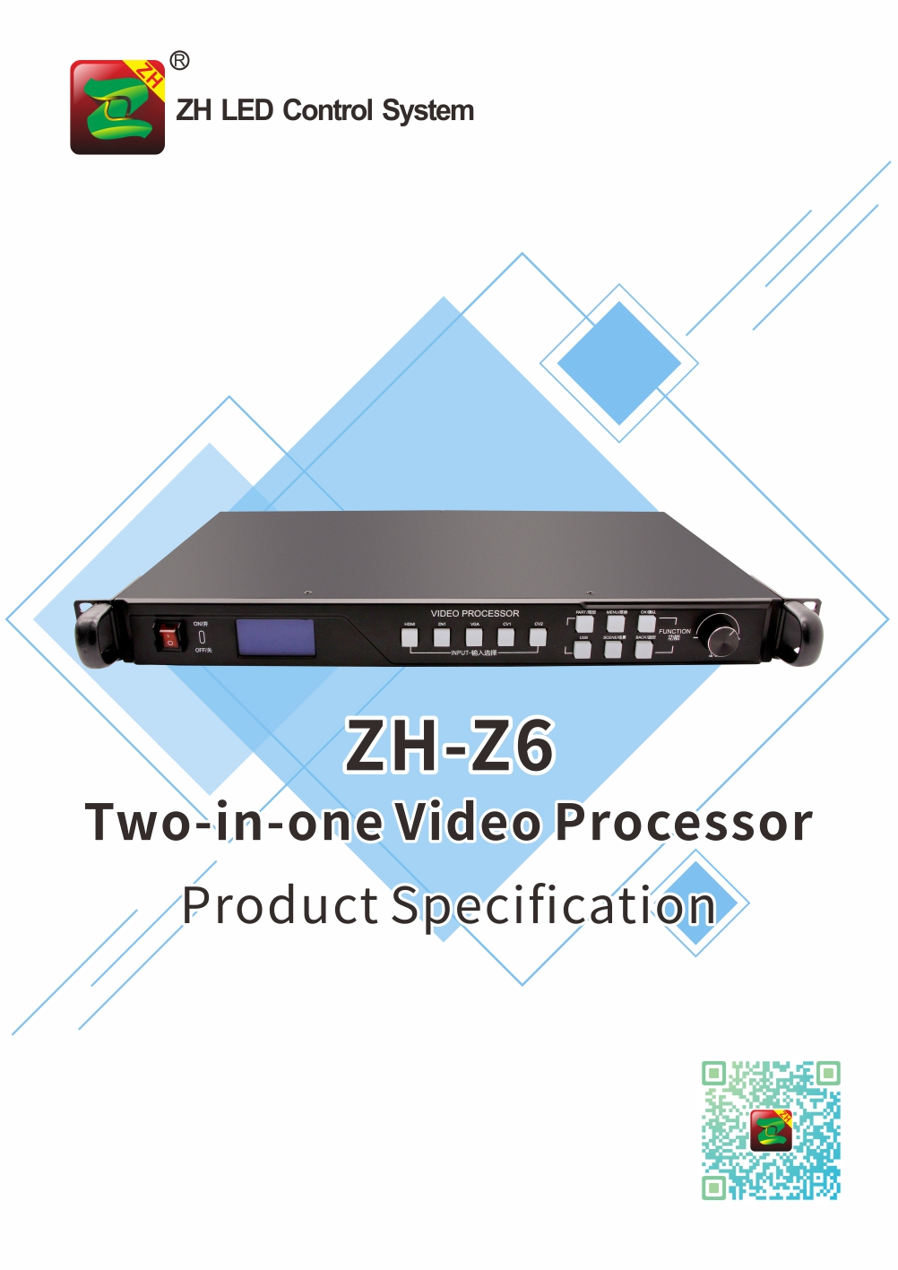

Product Specification
ZH-Z6
I. Product Introduction:
ZH-Z6 is one two-in-one product by high-definition video processor and sending card, which special developed for LED large screen display system. It uses industry-leading lossless scaling technology, supports high-definition HDMI / DVI input and standard gigabit network port output, and provides customers with LED large-screen high-definition display solutions. This product, while realizing fast switching of video sources, has simplified the customer's operation process to the greatest extent and truly achieved the purpose of simple operation. Support partial and full-screen modes switching by one-button, picture transition is smooth and stable. Multi-mode keyboard lock is provided, which can offer customers more options for safe operation. ZH-Z6 supports online upgrades, ensuring that customers can upgrade new features from time to time.

II. Functional Features
- Support multiple signal input: HDMI, DVI, VGA, CVBS*2, USB, audio *2;
- Support audio and video synchronous input: in addition to HDMI audio, can be connected to two external audio input for DVI\VGA video channel (PJ3.5);
- The following output signal interface is supported: LAN(RJ45)×6 (with network interface connection status indicator). The maximum resolution of the machine is 3.9 million pixels, support resolution customization. Pixels support: the Max width is 8192 and Max width is 2160.
- Audio (PJ35) ×1;
- Built-in U disk player function: U disk once plugging in, automatically play video or pictures of U disk;
- Support switching effects: fade in and fade out/direct cut switching effects are supported between signal source channels.
- Support image brightness adjustment, contrast, clarity, chroma adjustment;
- Support EDID configuration management: support reading, modifying, and customizing of EDID (Extended Display Identification Data);
- Support VGA correction function: solve the problem of black edge and deviation during the transmission of analog signal;
- Support Super Resolution zoom technology: video compensation processing algorithm.There is no limitation about picture size, and the details of the picture are retained, which reduce the out-of-focus phenomenon after the picture is put up for most times.
- Support function of black edge removing/clipping: solve the black edge problem caused by the input signal (especially the output signal of VGA signal and non-standard camera), and do arbitrary clipping for any signal source (still keep full screen);
- Support channel protection: protect the input and output I/O interfaces of the equipment to avoid the impact of over voltage and over current; The channels are independent and complementary to each other.
- Support brightness adjustment: adjust the brightness of the screen in real time and quickly;
- Support resolution customization;
- Support multi-function key locking to prevent misoperation;
- Support screen freezing;
- Support LED screen test: black screen, blue screen, red screen and other arbitrary display switch;
- Support remote controller;
- Support intelligent Settings;
- Support scenario invocation and saving;
- Support Chinese and English language Settings;
- Support multi-mode adjustment of buttons and knobs;
- Standard 1U case, standard LCD display screen, standard case portable, convenient for construction and installation;
- Wide power supply, voltage input range AC 100~240V, 50/60hz input;
- Support system online upgrade.

III. System Topology

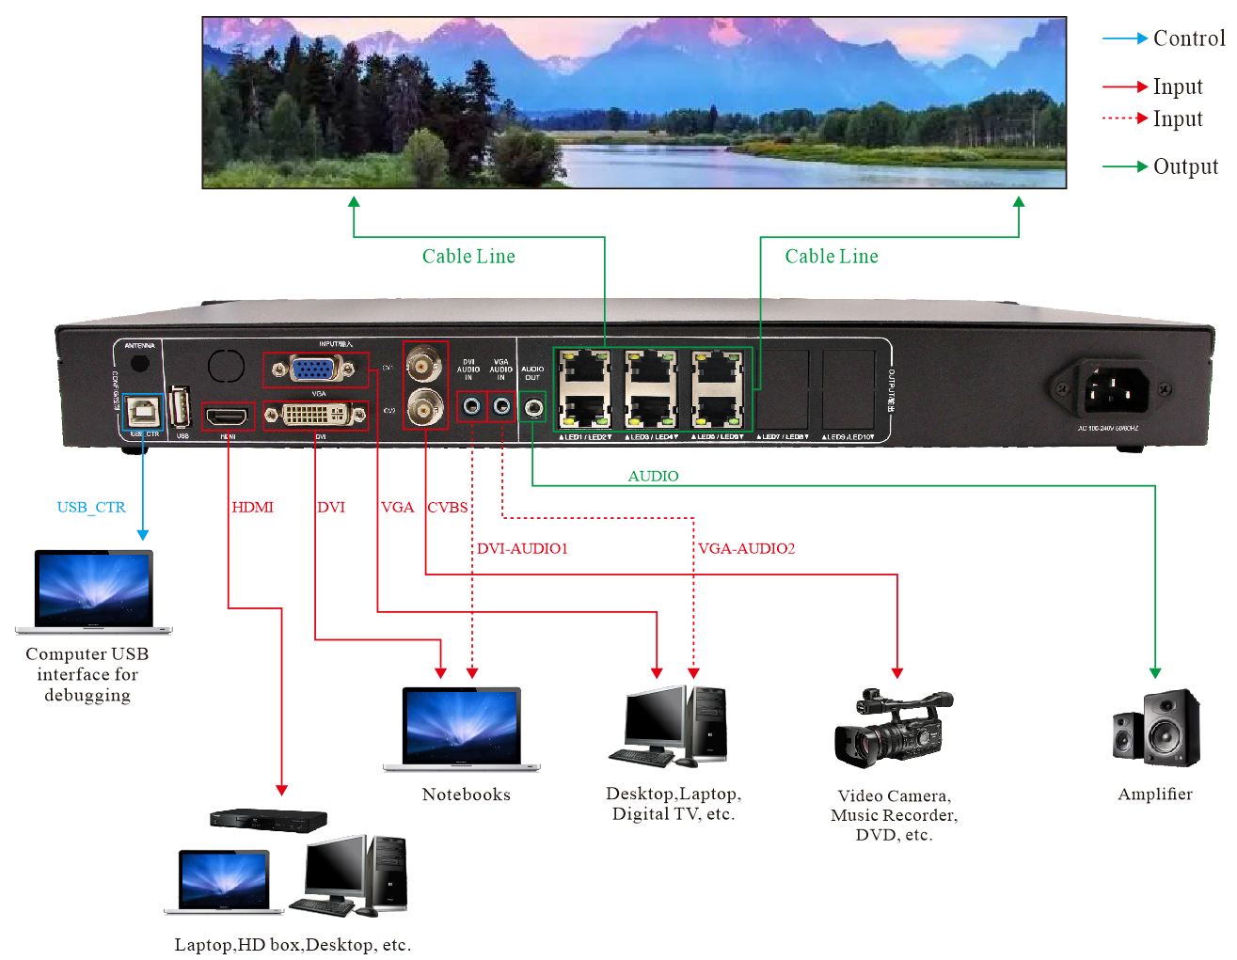
IV. Hardware Introduction:

The Front Panel
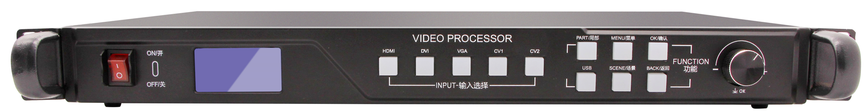
LCD
Button
Knob
Switch

Switch | The power switch
LCD | Displays detailed prompts for user actions
Knob | Adjust the LED screen resolution and confirm

Button Part Manual
HDMI | HDMI signal input button | PART/partial | Partial/full screen switching
DVI | DVI signal input button | MENU/the menu | Enter advanced settings mode
VGA | VGA signal input button | OK/conform | Select conform button
CV1 | CV1 signal input button | BACK/back | Back to the previous menu/lock function
CV2 | CV2 signal input button | SCENE/scene | The call button for default scenes
USB | USB signal input button

The Back Panel
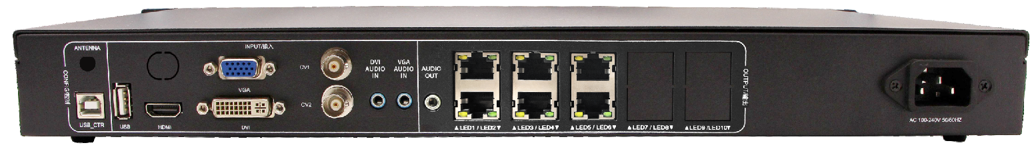
Input Port
Output Port
Power Port
Control Port

CONFIG/Control Port |  | INPUT/Signal Input Port |  | OUTPUT/Signal Output Port
ANTENNA | Remote controller antenna port | USB | USB input port | AUDIO | Audio output port
USB_CTR | System test port | HDMI | HDMI input port | S1/S2/S3/  S4/S5/S6 | Cable port working indicator light
 |  | VGA | VGA input port | LED1/LED2/LED3  LED4/LED5/LED6 | Output port
 |  | DVI | DVI input port | LED1/LED2/LED3  LED4/LED5/LED6
 |  | CV1/CV2 | CV input port
 |  | AUDIO1 | DVI audio input port
 |  | AUDIO2 | VGA audio input port

V. Parameters:
Input Standard:
Port | Quantity | Resolution specification
HDMI | 1 | EIA/ cea-861 standard, compliant with HDMI1.4 standard, supports HDMI input, audio data output
DVI | 1 | Support 1920* 1200/60hz and other resolutions conform to the VESA standard
VGA | 1 | Support 1920* 1200/60hz and other resolutions conform to the VESA standard
CV | 2 | PAL/NTSC
AUDIO | 2 | 3.5mm standard audio interface
USB | 1 | Standard USB2.0 interface

Output Standard:
Port | Quantity | Resolution specification
LED | 6 | Standard gigabit port
AUDIO | 1 | 3.5mm standard audio interface
Device specification:
Input power | AC 100~240V，50/60HZ,No more than 2A
Working temperature | -20~45℃
Volume | 483*225*44.5(mm,L*W*H)
Weight | 2.8KG

VI. Hardware Diagram:
Unit: mm


