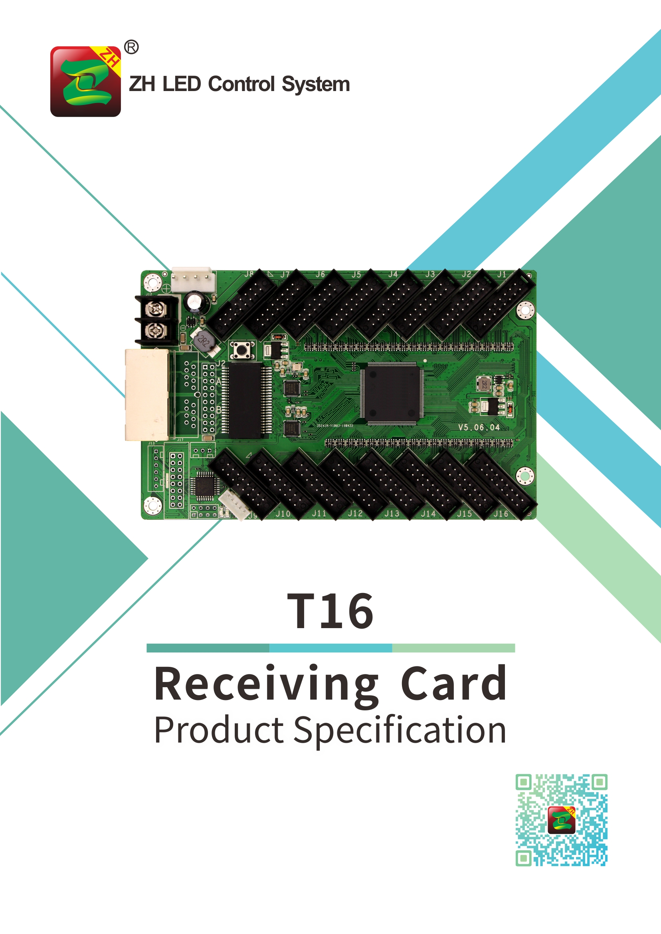

T16 Full Color Receiver
Specification
- Overview
The T16 full color receiver is a product carefully designed by ZH Software, to meet the rental market and engineering projects in LED industry. Taking new communication architecture, high refresh, high brightness, new grayscale scanning engine, nanosecond synchronization. Even under the poor communication status, it can still maintaining the smooth communication, which bringing users a more colorful and beautiful LED world!

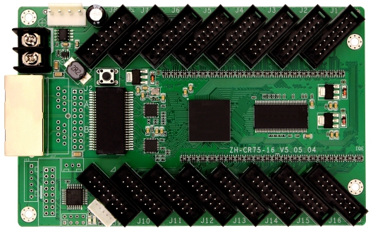

- Features
1. Integration of HUB75 interface, no need using hub adapter, more convenient;
2. Less connectors, less fault point, lower failure rate;
3. It supports conventional chips, which achieve high refresh, high gray, high brightness;
4. New grayscale engine, low grayscale, better performance;
- More perfect detail processing, eliminating the detail problems caused by the unit board design, such as dark line, low gray and red line, ghost, etc.
- Supports all conventional chips, PWM chips and lighting chips;
- Supports the static screen, and any scan type like 1/2~1/64 scans;
- Support arbitrary tap point, support data migration, can easily load any kind of screen like: special-shaped screen, spherical screen, creative display screen;
- Single card supports 32 sets of RGB signal output;
- Supports super large loading area
- Advanced design, high quality components, automated high and low temperature aging test, zero fault from factory.
- Supports ultra-wide working voltage: DC 3.5v ~6V, can effectively reduce the impact of voltage fluctuations;
- Support power reverse connection, which can protect circuit.

- Parameters

Network port function | Not partition the input and output, can interchangeably using
Synchronization between cards | Nanosecond synchronization between cards
Display effect | Refresh rate conventional chip. Static: refresh rate can reach 16000Hz  1/8 scan: refresh rate can reach 10000Hz; serial frequency 4.1MHz-31.25MHz
Gray level | 256 ~ 65536; gray scale is adjustable
Gray compensation | Compensation according to the refresh scan mode
OE control | OE control accurate to 8 nanoseconds, make low gray control more accurate
Chips | All mainstream LED driver chips such as conventional chips, PWM chips, and lighting chips;  The PWM chip supports hundreds of different specifications of chips such as MBI, MY, and SUM series
Scan mode | Regular scan mode and high refresh photo mode
Scan type | Any scan type between static and 1/32 scans
Data set | 32 sets of full color data
Multiple output | Support 1~8 output
Data exchange | Support 32 sets of data exchange freely
Module check point | Support any kind of check point
Gigabit communication | Support sending card and Gigabit network card to send
PCB Size | Height: 144.01mm，Width: 91mm
Input voltage | DC 3.5V~6V
Rated Current | 0.8A
Rated power consumption | 4W
Working temperature | -20℃ to 75℃

- Hardware Introduction:

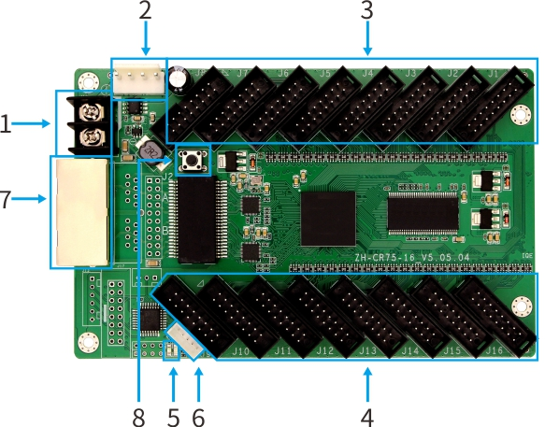

- Interface Function Table:

NO. | Name | Function | Notes
1 | Power input 1 | Connect DC 3.3~6V power, supply power to receiving card | Choose one of them
2 | Power input 2 | Connect DC 3.3~6V power, supply power to receiving card | Choose one of them
3、4 | HUB port | HUB75 port，J1~J12 link with display unit board
5 | Power Indicator | Indicate power status | Red
5 | Signal indicator | Indication signal transmission status | Green
6 | External interface | External interface of indicator and test button
7 | Network port A | RJ45，transport network signals | Double network port, free to enter and exit, the system Intelligent recognition
7 | Network port B | RJ45，transport network signals
8 | Test button | Own test program, it can realize four kinds of monochrome display of red, green, blue and white, horizontal scanning, vertical sweep, etc.

- Indicator Meanings：
Red indicator: When light on means power is on.
Green indicator: When fast flashing, means the data signal transmission is normal.

- HUB 75E Definition：
Data signal |  |  |  | Scan signal |  | Control signal
GD1 | blank | GD2 | E | B | D | LAT | GND
2 | 4 | 6 | 8 | 10 | 12 | 14 | 16
1 | 3 | 5 | 7 | 9 | 11 | 13 | 15
RD1 | BD1 | RD2 | BD2 | A | C | CLK | OE
Data signal |  |  |  | Scan signal |  | Control signal

Note: PCB board HUB75 port own E scan signal, supports display screen of 32 scan.

- External pin definition：
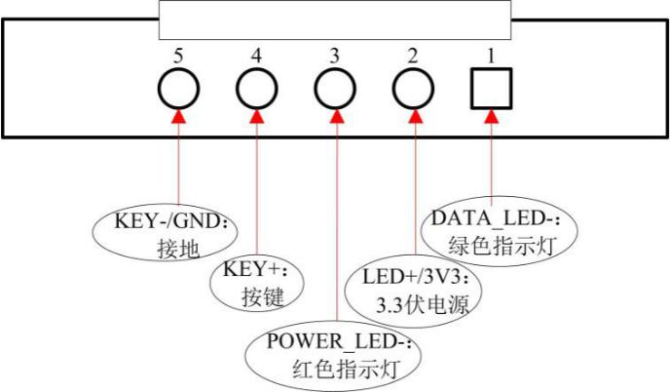

- Hardware Size Diagram: ( Unit:mm )



